Theory 4 - Classes of invertebrates
Arthropods

Cnidaria

Echinoderms

Molluscs

Poriferans

Worms

Identification of invertebrates

Use the key below to identify the organisms on the following page
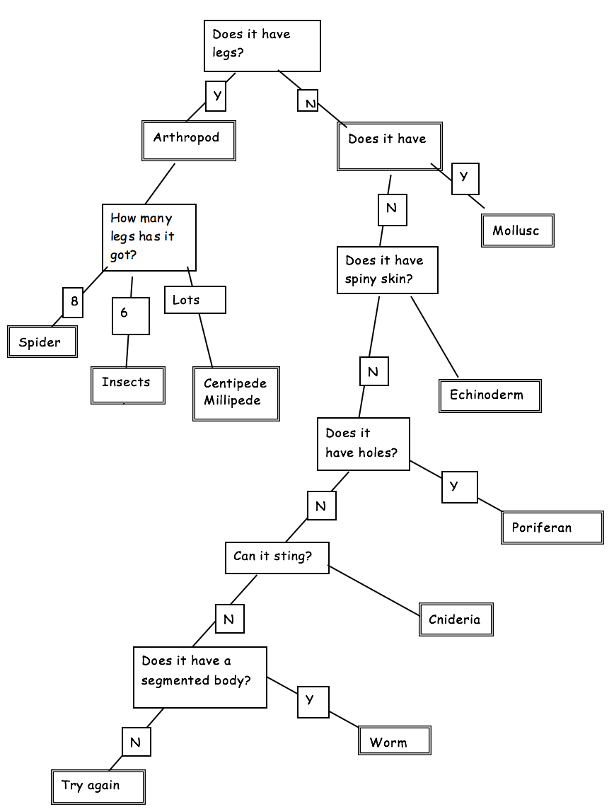

Animal image | Invertebrate class | Reason for classification
Jellyfish
Red back spider
Starfish
Earthworm
Sea sponge
Snail
Centipede
Sea urchin

